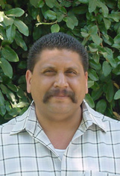
Jesse Díaz, Jr.
Jesse was born in Ontario, CA, was raised in Chino, CA, and currently resides in Ontario. He is 42 years old and married with four children, Nina 20, Jesse III 18, Jessica 15, and Elias 15. He was born to US born parents. His father was born in La Verne, CA, and his mother in Anthony, NM. His paternal family migrated from a small village in Aguascalientes, Mexico, named La Incarnacíon de Díaz, or “La Chona,” while his maternal family migrated from the state of Durango, Mexico. He is currently a PhD Student in Sociology at the University of California, Riverside, and has taught the following courses; Writing for Sociology, Inequality and Social Class, and American Social Problems. He aspires to become a professor in Sociology, specifically in the area of Race and Class Inequality with an emphasis on immigration. He has been the recipient of research grants, presented in many conferences on the issues of mental health among day laborers and Chicano gang members, and is a firm advocate of the union between activism and academic study. He is one of the founders of the March 25th Coalition, and the originator of the “Gran Paro Americano 2006,” during which millions of undocumented immigrants and their families removed their presence from the workplace and schools, and their economic contributions to stores and markets in a symbolic gesture of international solidarity and celebration.

