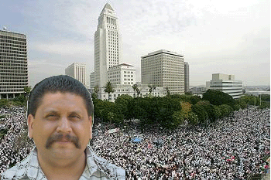
Jesse Díaz is a co-founder of the Los Angeles March 25th Coalition, which organized a historic demonstration of over one million for immigrant rights. He was instrumental in initiating the call for the "Gran Paro Americano 2006" put out by the March 25th Coalition. This call led to a nationwide boycott and political strike of immigrant workers in which millions protested, went on strike, and walked out of school. You are invited to attend a public meeting featuring Jesse and to join the discussion about the next steps in the movement for amnesty and equal rights for all workers -- U.S. born and immigrant alike.

Immigrant Rights Activist from Los Angeles
Speaking Tour: Jesse Diaz Jr.

Schedule of Activities:

Thursday, 8/24
- 6pm - English High School, 144 Mc Bride St., Jamaica Plain
Friday, 8/25 –
- 1pm-3pm – Amherst, Meeting with immigration rights activists and students. U-Mass. Amherst.
- 7pm-9pm - Encuentro 5, 33 Harrison Avenue, Boston. Strategy Session with pro undocumented immigrant right activists.
Saturday 8/26
- 1pm -- Nobel Bookstore presentation - 466 Haverhill St. Lawrence
- 5pm -- Meeting with Spanish speaking immigrants at Centro Presente, 54 Essex St., Cambridge
Sunday 8/27
- 2pm -- Sacco and Vanzetti Memorial Rally and Parade at Stony Brook T Station Park, Jamaica Plain.
- 5pm -- Chelsea Uniting Against the War picnic, 5 Clyde St., Chelsea

For more information contact the Boston May Day Coalition
info@bostonmayday.org - 617-482-6300
www.bostonmayday.org

AMNESTY FOR ALL UNDOCUMENTED IMMIGRANTS, NOW!
SI. SE PUEDE!

